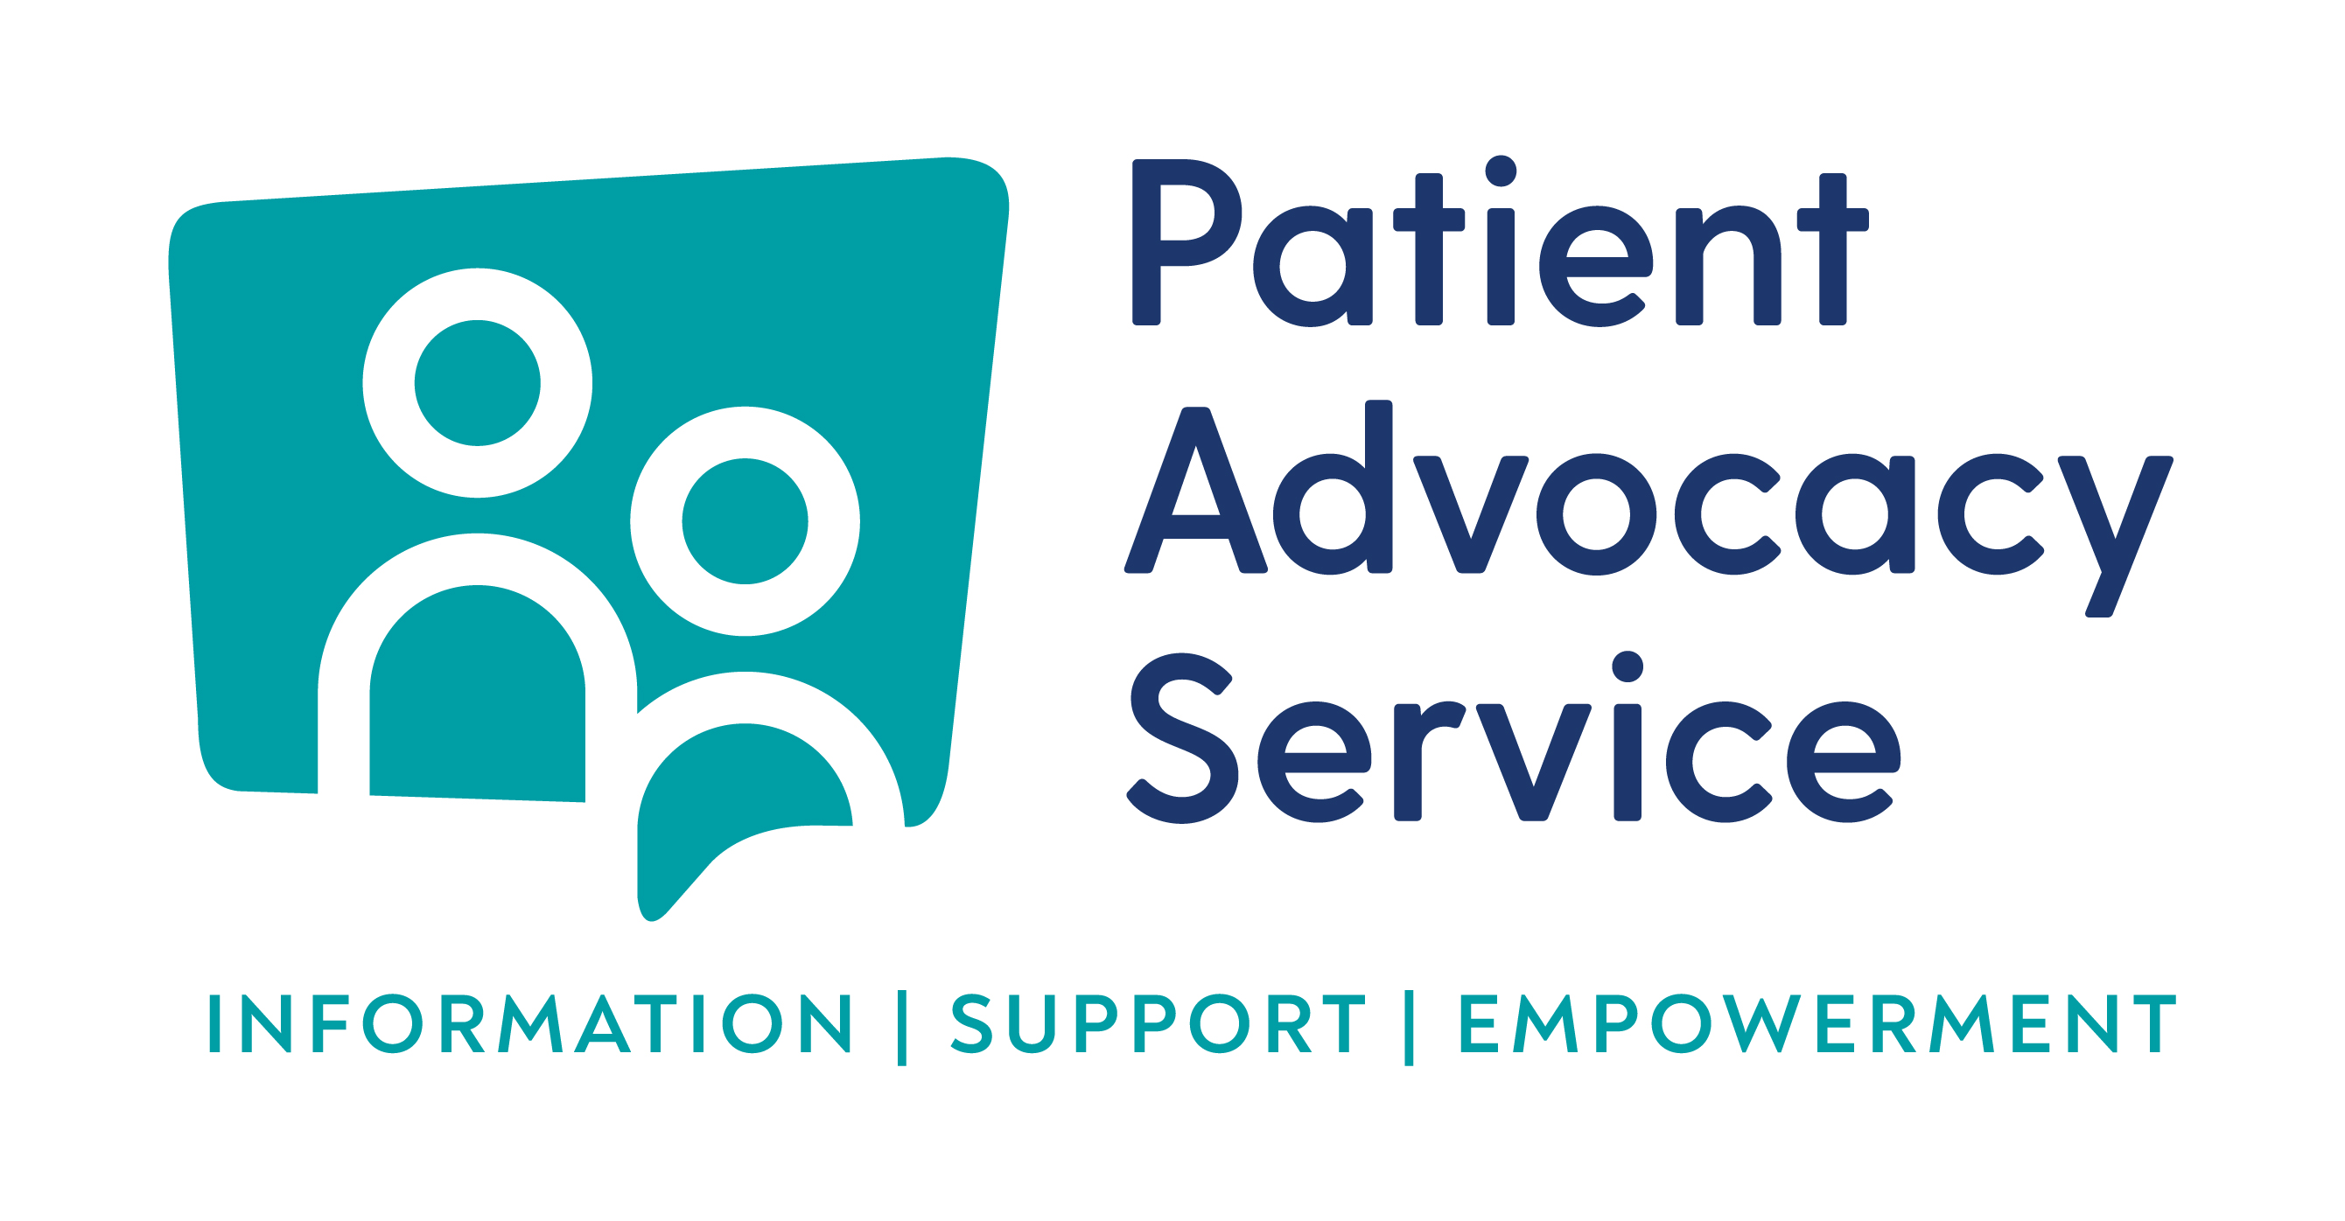

Enquiry Line: 0818 293003

Enquiry Form

The Patient Advocacy Service provides a free, independent and confidential service to help users of public acute hospitals making or intending to make a formal complaint through the HSE Your Service, Your say complaints process in relation to the care they have received, and adheres to the highest professional standards nationally.
If you would prefer to talk to an advocate directly please contact us by phone rather than completing this form.

However, if you would like to provide your information in written format please complete this form and we will be in touch.
YOUR DETAILS:
Name:
County:
Telephone:
E-Mail:
Hospital complaint relates to:

OUTLINE OF ISSUE

IF YOU HAVE AN ACCEASSIBILITY REQUIREMENTS PLEASE LET US KNOW
HOW WOULD YOU LIKE US TO CONTACT YOU ?
Telephone |  |  |  | E-Mail
Face to Face |  |  |  | SLIS / IRIS
Skype / Facetime |  |  |  | Other
Is there anything else you would like to let us know about contacting you?

We will keep your information confidential. There are some occasions when an advocate will have to give your personal information without your agreement. This will be if:

- you are in danger,
- you are a danger to someone else
- a court order asks for your information
- a child is in danger of abuse

By signing this form you are consenting to your data being processed by the Patient Advocacy Service and retained on a case management system in accordance with the Patient Advocacy Service Data Protection policy.
Further details of the Patient Advocacy Service data protection policy are available at patientadvocacyservice.ie

________________________________ _______________________________
SIGNATURE DATE

