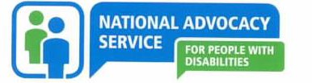 | 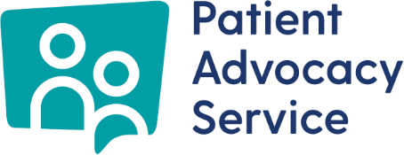

Gender Pay Gap Report

NATIONAL ADVOCACY SERVICE FOR PEOPLE WITH DISABILITIES

Version: 1
Date: 14th November 2025

Table of Contents
Chair Introduction 3
Introduction 4
Overview 5
Mean and Median Gender Pay Gap 6
Quartile Pay Bands 6
Bonus and benefit-in-kind 7
Factors that can have an impact on the gender pay gap 7

Chair Introduction
The Gender Pay Gap Information Act, 2021, requires medium and large employers in Ireland to report and publish details of the average hourly rates of pay of women compared to men. The National Advocacy Service for People with Disabilities (NAS) is strongly committed to this process, and I am pleased to publish our Gender Pay Gap Report for 2025.
This is NAS’s first Gender Pay Gap Report. Our analysis shows that the headline median gender pay gap is 5.61% and the mean is 1.99 % for 2025.
NAS’s remuneration processes ensure that men and women are paid equally for doing equivalent jobs with similar levels of experience, qualifications and skills this is due to having set published pay scales for all staff.

The NAS Board of Directors remains committed to continuing to take actions to promote an equal, diverse and inclusive workplace. We are committed to providing the necessary support to encourage career development and ensure that our recruitment processes are free from bias and help to attract diverse talent.

Rosemary Smyth
Chair

Introduction
The Gender Pay Gap Information Act 2021 requires organisations to report on their hourly gender pay gap across a range of metrics. Organisations with over 250 employees have been required to report on their gender pay gap since 2022. From 2024, organisations with over 150 employees are required to report on their gender pay gap. In 2025, organisations with over 50 employees are being asked to report on their gender pay gap for the first time.

The gender pay gap is defined as the difference in the average hourly wage of men and women across a workforce. It is important to clarify that if an organisation reports a gender pay gap, it does not mean women are paid less than men for doing the same job. It may however show that, on average, men occupy more higher-paying roles than women.

The National Advocacy Service for People with Disabilities (NAS) is the legal entity and a dual funded organisation providing two independent advocacy services being the National Advocacy Service for People with Disabilities wholly funded by the Citizens Information Board and the Patient Advocacy Service, wholly funded by the Department of Health.

The National Advocacy Service for People with Disabilities (NAS) was established as a company in 2013 and is funded by the Citizens Information Board (CIB). The Citizens Information Board has a mandate under the Citizens Information Act 2007 to provide advocacy for people with disabilities. All CIB funded activities undertaken by NAS are as per a Service Level Agreement between CIB and NAS. NAS provides an independent, confidential and free representative advocacy service that works exclusively for each person using the service and adheres to the highest professional standards. NAS ensures that when life decisions are made, due consideration is given to the will and preference of people with disabilities and enables them to protect their rights. NAS has a particular remit to work with those who have limited informal or natural supports.

The National Advocacy Service is provided through four regions and a National Office which is based in Dublin. The regions are as follows:

Region | Including
Greater Dublin | Dublin, Fingal and Wicklow
Northeast & Midlands | Cavan, Laois, Longford, Louth, Kildare, Meath, Monaghan, Offaly and Westmeath
Western | Clare, Donegal, Galway, Leitrim, Limerick, Mayo, Roscommon and Sligo
Southern | Carlow, Cork, Kerry, Kilkenny, Tipperary, Waterford and Wexford

In 2018, NAS won a competitive tendering process to be the provider of an independent Patient Advocacy Service (PAS) commissioned by the National Patient Safety Office in the Department of Health. The expansion came about as a result of the strong reputation NAS has developed as a leader in the field of advocacy in Ireland, and places NAS in an influential position to positively promote advocacy in the years to come.

The Patient Advocacy Service became operational in October 2019. The service is an independent, free and confidential service that provides information and advocacy to people who want to make a formal complaint about an experience they had in a HSE funded public acute hospital, HSE operated or private Nursing Home or after a patient safety incident. The Patient Advocacy Service is available across Ireland and operates from a national office based in Dublin City Centre. The existing contract with the Department of Health continues until the end of October 2027 with the possibility of extension until 2029.

Overview
NAS’s workforce as of the “snapshot date” 20th June 2025 was 82. On this date the workforce was made up of 69 women and 13 men. This equates to a distribution of 84% female employees and 16% male. Of the total workforce 63 females are full time, 13 males are full time, 6 females are part-time, and no males are part-time. At any point some staff can be on different types of leave on the snapshot date, such as, paid maternity leave, unpaid maternity leave, parents leave etc.

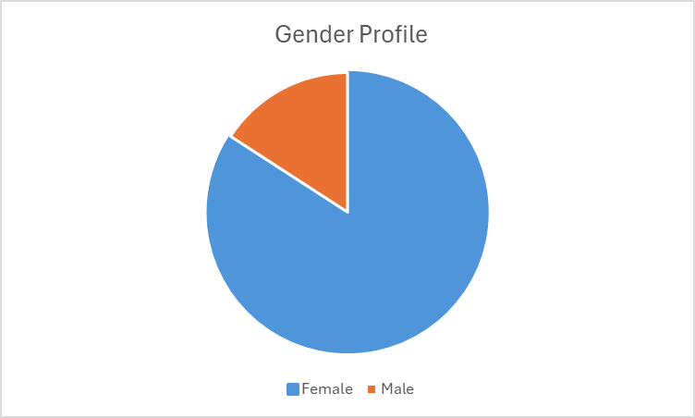

All persons employed by NAS on the snapshot date are included in the gender pay gap calculations including employees not rostered to work on that date and employees on leave.

Mean and Median Gender Pay Gap
The Gender Pay Gap calculates the percentage difference between the average earnings of males and females irrespective of their role, using the following measures:
Mean Gender Pay Gap
This shows % difference between the average hourly rate pay for males and average hourly rate of pay for females:
(average male hourly rate) – (average female hourly rate) x 100
Average male hourly rate
Median Gender Pay Gap
This shows the % difference between the median hourly rate of pay for males and median hourly rate of pay for females:
(median of male hourly rates) – (median of female hourly rates) x 100
Median of male hourly rates

The mean is the average. It is calculated by getting the difference between the average hourly rate of pay for males and the average hourly rate of pay for females (male hourly rate minus female hourly rate), expressed as a percentage of the male hourly rate. If this figure is negative, the average hourly rate of females is higher than the average hourly rate of males on the snapshot date. If this figure is positive, the average hourly rate of males is higher than the average hourly rate of females on the snapshot date.
The median is the figure that falls in the middle of a range where the salary of all relevant employees is listed, from the lowest to the highest. This can provide a more accurate representation of the ‘typical’ differences in pay.

Quartile Pay Bands
Organisations must report on the percentage of employees who fall within the lower, lower middle, upper middle and upper quartile hourly pay bands. Dividing employees in to pay graded groups from lowest to highest helps examine pay across different levels of the organisation.

In order to group employees in Quartile Pay Bands, all employees are listed from lowest to highest, based on their hourly rates. The employees are then divided into four equal groups or Quartiles.

Bonus and benefit-in-kind
Figures must also be provided for bonus payments or benefit-in-kind payments if these apply. In line with public sector guidelines, NAS does not pay any bonus remuneration or provide employees with any benefit-in-kind. Benefit in Kind refers to remuneration other than money not included in the regulation’s definition of “ordinary pay”.

Factors that can have an impact on the gender pay gap
Every employee is paid equally for work that is the same or similar or for work of equal value. Differences between what employees are paid can be impacted by a number of factors including:

- Length of service – incremental pay increases may mean that new joiners are paid less than more experienced employees.
- Occupational segregation – some job categories or occupations may have traditionally attracted more females than males or vice versa.
- A small number of higher or paid employees can affect the average figures.
- A large number of lower paid employees can affect the average figures.

If an organisation reports a positive gender pay gap, it does not necessarily mean that females are paid less than males for doing the same job but shows that on average males occupy higher paid roles than females. If an organisation reports a negative gender pay gap, it does not mean that males are paid less than females for doing the same job, it shows on average females occupy higher paid roles than males.

Gender Pay Gap Figures

Quartiles

Quartiles are calculated by dividing the data into four equally sized groups based on hourly pay. 16% of the organisation’s workforce is male and the quartile figures presented shows that for the upper quartile hourly pay band that there are more males compared to the upper middle, lower middle and lower hourly pay bands less females.

Median and Mean Pay Gap Temporary compared to Permanent employees.

For permanent and temporary employees there was no median gender pay gap reported on the snapshot date as there were two part-time employees.

 | All | Male | Female
Average / Mean - Temporary contract | 24.92 | n/a | 24.92
Median - Temporary contract | 26.80 | n/a | 26.80

Median and Mean Pay Gap Part-time and Full Time Employees

For part-time and full-time employees there was no median gender pay gap reported on the snapshot date as there were 7 part-time employees all of whom were female employees.

 | All | Male | Female
Average / Mean - Part time only | 28.32 | n/a | 28.32
Median - Part time only |  | n/a | 28.13

2024 Retrospective
NAS continually seeks to improve offerings to our employees. We have policies and procedures in place to support all employees to ensure that they are supported in times of family commitments and ill-health. The organisation currently works on a hybrid basis which supports our employees to balance home and working responsibilities. Our current Board comprises 6 females and 3 males and 54% of our operational manager roles are held by female employees. The focus for the next 12 months is to strengthen our diversity, equity and inclusions policies.

The overall calculations for 2024 are:
 |  |  | A | B
 |  | All | Male | Female | Gender Pay Gap / Difference
1 | Average / Mean - All | 27.73 | 28.20 | 27.64 | 1.99%
 | Median - All | 27.52 | 29.01 | 27.38 | 5.61%
2 | Average / Mean - Part time only | 28.32 | n/a | 28.32 | n/a
 | Median - Part time only |  | n/a | 28.13 | n/a
3 | Average / Mean - Temporary contract | 24.92 | n/a | 24.92
 | Median - Temporary contract |  | n/a

